**Environmental Control Systems (ECS) Door Redesign**

**Final Proposal**

**Jake West**

**Alexander Soto**

**Michael Wilson**

**Andrea Hernandez**

**Sam Mangialardi**

**Timothy Anderson**

**Fall 2020**

**Project Sponsor: Northrop Grumman, Daniel Johnson**

**Faculty Advisor: David Trevas**

# DISCLAIMER

This report was prepared by students as part of a university course requirement. While considerable effort has been put into the project, it is not the work of licensed engineers and has not undergone the extensive verification that is common in the profession. The information, data, conclusions, and content of this report should not be relied on or utilized without thorough, independent testing and verification. University faculty members may have been associated with this project as advisors, sponsors, or course instructors, but as such they are not responsible for the accuracy of results or conclusions.

# EXECUTIVE SUMMARY

For the Northrop Grumman teams final report, the team has gone over the final design developed during the semester, as well as laid out the next steps in order to have a working design by the end of the next semester. The team has been tasked by Northrop Grumman to redesign the Environmental control system door, specifically in relation to their Antares rocket. This door must close as the ECS nozzle is removed from the inlet in the fairing and stay properly sealed throughout the duration of the flight. The design needs to be lightweight, scalable, not interfere with other systems nearby. There are a variety of engineering requirements that must be met by specified factors of safety in order to be considered as a legitimate design to be implements on their systems.

The design that was chosen by the team was a twisting latch design. This design came out ahead of the other three major contenders as the final design, as it excelled in many of the requirements necessary. The latch functions using a torsion spring to twist a shaft with the latch on it. While open, the latch is out of the way of the door and is held in place by a retaining pin. As the door closes, the pin is pressed down by the door, allowing the shaft to freely spin 180 degrees, until the latch coves the bottom of the door. At this point, the latch is in tension, and the threads that drive the shaft have enough friction to prevent further rotation.

To test the design and make sure it can handle the conditions of an actual flight, the team has derived three tests for the device. These will test the Vibration load, temperature, and load that the system will be experiencing in flight. These tests will use the budget given to us by Northrop Grumman, to design and build test jigs in order to conduct test trials of the performance of our design. The budget will also be used to create full scale models of the device, both in 3D printed materials and in full metal. Basic tests and tolerances can be investigated with the 3D printed part, while the major tests with be on the full metal design.

# TABLE OF CONTENTS

Contents

DISCLAIMER 1

EXECUTIVE SUMMARY 2

TABLE OF CONTENTS 3

1 BACKGROUND 1

1.1 Introduction 1

1.2 Project Description 1

2 REQUIREMENTS 2

2.1 Customer Requirements (CRs) 2

2.2 Engineering Requirements (ERs) 3

2.3 Functional Decomposition 4

2.3.1 Black Box Model 4

2.3.2 Functional Model/Work-Process Diagram/Hierarchical Task Analysis 4

2.4 House of Quality (HoQ) 4

2.5 Standards, Codes, and Regulations 5

3 Testing Procedures (TPs) 2

3.1 Testing Procedure 1: Vibrations Test 2

3.1.1 Testing Procedure 1: Objective 2

3.1.2 Testing Procedure 1: Resources Required 2

3.1.3 Testing Procedure 1: Schedule 2

3.2 Testing Procedure 2: Temperature Test 2

3.2.1 Testing Procedure 2: Objective 2

3.2.2 Testing Procedure 2: Resources Required 3

3.2.3 Testing Procedure 2: Schedule 3

3.3 Testing Procedure 3: Load Test 3

3.3.1 Testing Procedure 3: Objective 3

3.3.2 Testing Procedure 3: Resources Required 3

3.3.3 Testing Procedure 3: Schedule 3

4 DESIGN SELECTED – First Semester 4

4.1 Design Description 4

4.2 Implementation Plan 6

5 CONCLUSIONS 9

6 REFERENCES 10

7 APPENDICES 11

7.1 Appendix A: Descriptive Title 11

7.2 Appendix B: Descriptive Title **Error! Bookmark not defined.**

# BACKGROUND

## Introduction

In this project, the Northrop Grumman capstone team from NAU will be designing a latching door to be implemented on Northrop Grumman’s rockets. The rockets require an inlet on the fairing of the rocket, to allow airconditioned air to be pumped into the cabin of the vehicle. As the rocket launches, the inlet must be sealed shut in order to maintain the internal pressure of the cabin. The heritage design has had problems with maintaining a seal during flight, causing air the suddenly force open the door and lose some of the internal pressure. This sudden leak of air has potential to cause serious damage to the vehicle in flight and could even result in a mission failure. Solving this potential issue helps to eliminate risks of failure, which can cost millions of dollars put towards the project. Our teams' goal is to create a closing and latching system that effectively seals of the inlet and will remain closed throughout the entire flight.

While the team is currently designing the system based off Northrop Grumman’s Antares rocket, one of the main goals is to allow the design to be scalable in order to be implemented onto other systems. One of the major problems that lead to the previous design to fail occurred when the rocket took new trajectories. It is important that the design will work in many different circumstances to allow for the design to be successful from different launchpads. Creating a design that is versatile, scalable and reliable will save Northrop Grumman valuable resources that can be used to develop and improve on other systems.

## Project Description

Following is the original project description provided by the sponsor:

*Most vehicles that Northrop Grumman Space Systems flies have a requirement to keep their payload air conditioned. This air is blown into the fairing through a specific door in the fairings of the vehicle prior to launch. In the past, the use of heritage designs to meet the needs of new or developing vehicles was relied upon for these doors. However, recently, there has been an undesirable side effect discovered largely due to this method. The main issue has been traced back to the way these doors are kept closed during flight. The latching method used has been discovered to be sensitive to different flight trajectories. The way we currently latch our ECS doors is to use hook and loop (Velcro) in combination with a hinge that is precisely shimmed to allow the mating halves to properly align. This ensures the strongest possible bond and has worked well in the past due to its simple nature. However, we have found that with steeper trajectories and higher pressure differentials between the interior and exterior surfaces of the fairing, there can be a tendency for the door to “burp” or open during flight.*

*NGC is requesting that NAU select one team to design, analyze, and build a prototype door system that is insensitive to pressure differences that may be seen during flight.*

# REQUIREMENTS

The project requirement consists of customer needs and engineering requirement the team had to compile to define the goals and objects in qualitative and quantitative values for the design process. These characteristics of the design are then analyzed via a quality function deployment. Then, the overall needed functions of the design are visually shown in functional decomposition models. Lastly, the standards observed in the design are discussed.

## Customer Requirements (CRs)

Various customer requirements have been discussed with the project sponsor, Northrop Grumman, and the team. These are all qualitative requirements that the ECS door design must fulfill as agreed upon by Northrop Grumman and the team. Majority of the customer requirements originated in the project proposal provided by Northrop Grumman. Additional customer requirements were added by the Capstone team as they were determined to be essential for a successful design.

* Ease/Safety of Installation: The door design must be able to be easily installed into the vehicle fairing at the launch site. The installation shall not require any specialized, uncommon tooling and can be installed by no more than two people due to the limited access on site.
* Scalable: The design shall be able to be scaled for use across various launch vehicles. While the door is being initially designed for the Antares rocket, the goal is to create a design that can be implemented across the entire selection of Northrop Grumman’s launch vehicles.
* Reopenable: The ECS door shall be able to be opened from the outside. There is potential for accidental closure of the door during installation and during insertion of the ECS nozzle. The installation team must be able to easily open the door on site.
* Withstand Pressure Differential: The design will potentially be implemented into various launch vehicles with different launch trajectories. These trajectories cause various pressure differentials, and the door must be able to remain closed when exposed to these various pressures.
* No Contaminates: The design materials shall not generate any foreign object debris (FOD) such as sparks, shavings, dust, or material off-gassing. The location of the door is close to sensitive satellites in which FOD can affect.
* Not Based on Gravity: The closure of the door design shall not rely solely on the force of gravity. Additional systems must be implemented for closure to ensure an accurate design.
* Door Closes on Launch: The design must automatically close upon removal of the ECS nozzle. It is acceptable for the ECS nozzle to hold the door open with direct contact.
* No Interference with Surrounding Systems: The components of the door shall not interfere with nearby systems or operation of the rocket fairing. Any system interference can create potential for mission failure.
* Professionalism: The team shall conduct themselves in a professional manner throughout their work with Northrop Grumman. The team recognizes that they not only represent themselves, but also the reputation of NAU’s mechanical engineering program.
* Minimal Effect on Aerodynamics: The design must be externally flat and free of any major protuberant components to minimize potential effects on overall aerodynamics of the launch vehicle.
* Electrostatic Discharge Safe: The design shall not have any major potential electrostatic discharge (ESD) as any discharge can affect the performance of the sensitive satellite systems nearby.
* Door Status Indicator: This indicator is an optional stretch goal. An indicator that remotely communicates that status of the door as open or closed is an optional customer requirement that has been requested by Northrop Grumman.

These various customer requirements were rated by the team on a scale of 1-10 to allow the team to prioritize the most important requirements. It has been determined that the highest priority customer requirements are withstanding pressure differentials, automatic closure upon vehicle launch, and no interference of surrounding systems. The customer requirement that is the lowest priority is the optional door status indicator. The rating of all customer requirements is shown below in Table #1.

Table 1: Rating of Customer Requirements

|  |  |  |
| --- | --- | --- |
| **#**​ | **Customer Requirement**​ | **Rating**​ |
| *1*​ | Ease/safety of installation​ | 7​ |
| *2*​ | Scalable​ | 8​ |
| *3*​ | Reopenable​ | 4​ |
| *4*​ | Withstand Pressure Differential​ | 10​ |
| *5*​ | No contaminates ​ | 8​ |
| *6*​ | Does not use gravity or acceleration​ | 6​ |
| *7*​ | Activates on launch​ | 10​ |
| *8*​ | Does not interfere with nearby systems​ | 9​ |
| *9*​ | Professionalism​ | 5​ |
| *10*​ | Does not influence aerodynamics​ | 9​ |
| *11*​ | ESD safe​ | 7​ |
| *12*​ | Indicates open/closed status​ | 1​ |

## Engineering Requirements (ERs)

The various engineering requirements are quantitative characteristics that were provided by Northrop Grumman. These requirements are necessary to successfully fulfill the intended use of the design. These engineering requirements help to ensure a high standard of design performance, reliability, durability, and safety. Many of these engineering requirements are directly related to customer requirements and give a quantitative measurement to fulfill the customer requirement.

* Safety Factor: All metal components shall meet the minimum safety factors of 1.6 to yield and 2.0 to ultimate. All plastic or composite components shall meet the minimum safety factors of 2.0 to ultimate and 2.3 to buckling. These safety factors help to prevent any potential failure of components that can potentially lead to door failure.
* Vibrations: The design shall withstand a vibration test with a load of 73 Gs while in the closed position. The vibration test helps to ensure the reliability of the latching mechanism during launch of the vehicle.
* Pressure Differential: The door shall withstand a pressure differential of up to 7.5 psi during flight. Failure to withstand this pressure differential was the main issue of the original design. The new design must be able to withstand the pressure differential that the previous design was not able to withstand.
* Budget: The team shall not exceed the allocated budget of $8,000. This budget includes all costs of materials, prototypes, and out-sourced manufacturing.
* Dimensions: The maximum inlet area shall not exceed 203 ${in}^{2}$. The design will be scaled for implementation on various launch vehicle. This is the maximum potential area required.
* Weight: The overall mass of the design shall not exceed 5 lbs. This weight limit is important as overall weight of the launch vehicle must not have major effects due to the door.
* Pressure Limit: The compressive stress applied to the surrounding fairing area of the door shall not exceed 810 psi. This compressive pressure limit ensures that the design will not cause any damage that can potentially compromise the integrity of the fairing structure.

## Functional Decomposition

### Black Box Model

The black box model creates a visual description of the operations needed for product to perform the desired outcomes. The generalized goal of the project is to close a door. Therefore, the inputs and outputs break down into three flow categories: energy, material, and signal. Figure 1 shows the functions required for the overall redesign goal. For example, the team ultimately designed a system which solely realize on visual confirmation for the closed door. Therefore, the only signal in is visual in Figure 1.

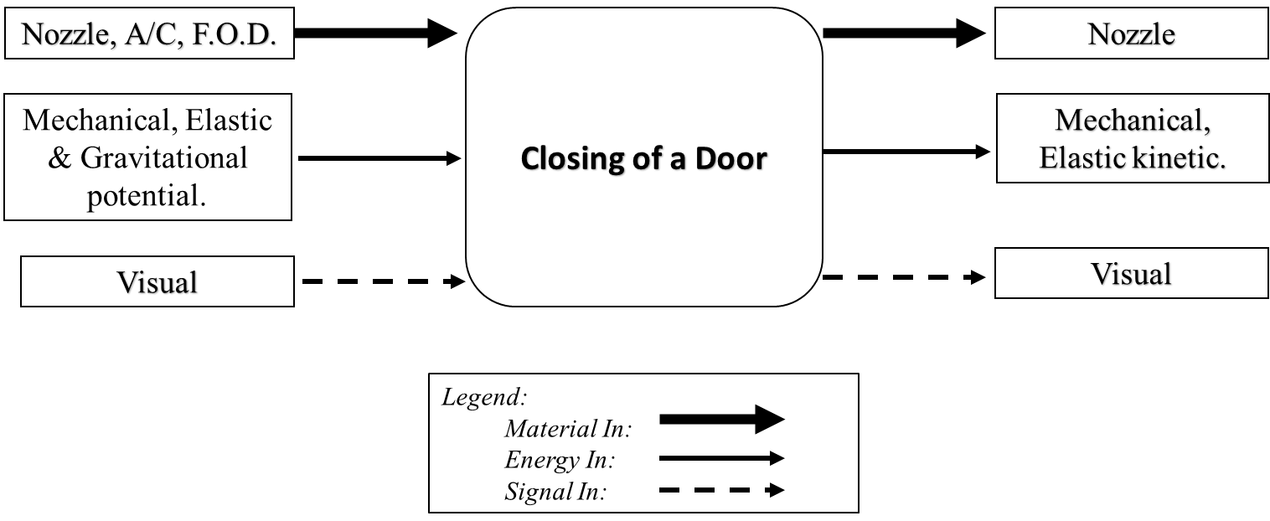

Figure 1: Black Box Model

Since the functions considered are simplified by only taking into account the beginning and end, the team formulated concepts that complete the objectives of the project without restricting creativity from specificity.

### Functional Model/Work-Process Diagram/Hierarchical Task Analysis

Further analysis on the black box model leads to functional decomposition. The outcome, Table 2, is a detailed look into the sub functions of each flow input and output of the black box model of Figure 1. The division gives emphasis on how functions were achieved throughout the use of the design and the results of the material, energy, or signal flow path.

Table 2: Functional Model Basis



From Table 2 above it is clear the specific input flows the team used in the finalized design for closing the door with the latching system.

## House of Quality (HoQ)

The use of a house of quality ensures the customer requirements and engineering requirements are examined through a quality function deployment, QFD, which is an engineering technique used to make sure customer needs are correctly translated into specific design inputs of a device being designed. The proceed evaluates customer needs to quantifiable and measurable criteria. The team create the weighted values of each customer requirement from the project proposal and client input to prioritize design functions and qualities for the final concept. Then, relationships between requirements were compared on a scale of 9 (strong), 3 (moderate), 1(weak), or no value. Since the engineering requirements are based on customer needs for the design, there is at least one engineering requirement to one customer requirement.

In summary the results showed that the most important engineering requirement to keep in mind thought the design process will be the weight limitation. As we consider safety factors for yield, ultimate and bucking of a material we effect the weight of the system. Also, wanting to keep the design easy and safe to install, the team must review the weight value. Other factors such as cost, gravity, additional component for an ESD safe design can further add to the total design’s weight. Detailed team results of the House of Quality can be seen in Appendix A.

## Standards, Codes, and Regulations

Northrop Grumman has company standards that the team’s design must meet. The first standard provided is for tolerancing in which all parts must have a tolerance of ±1/1000 in. This is the standard company tolerance which must be met. Another important standard provided by Northrop Grumman is that all metal parts must have a safety factor of 1.2 to yield and 2.0 to ultimate. Additionally, all plastic or composite parts must have a safety factor of 2.0 to ultimate and 2.3 for buckling. These safety factors are essential to help mitigate potential failure of any parts or components.

Table 3: Standards of Practice as Applied to this Project

|  |  |  |
| --- | --- | --- |
| **Standard Number or Code** | **Title of Standard** | **How it applies to Project** |
| ASNI/AAMI HE 74:2001 | Human Factors Design Process for Medical Devices | Helps in the design of how the device with interface with the user in a safe manner. |
| ANSI Y14.5 | ASME Y14.5 2018 | Authoritative guideline for the design language of Geometric Dimensioning and Tolerancing |

# Testing Procedures (TPs)

The team must formulate a range of testing procedures to ensure the design being considered does in fact satisfy the deliverables, specifically the engineering requirements. Therefore, the team will be conducting vibration, pressure, and load testing in the next steps of the engineering design process so verify the design is functional, reliable, and robust.

## Testing Procedure 1: Vibrations Test

The vibrations test will test how well our design can withstand the 73 Gs required during launch and flight. This test will be conducted once we have our device machined with the necessary AISI 304 Steel. This will be one of our last tests that is conducted once we have done machining

### Testing Procedure 1: Objective

We will run a series of vibration tests with equipment at Northrop Grumman facilities to see how many Gs our design can handle before failure. Testing the vibrations will determine how we change our design to handle the 73 Gs after analyzing the outcomes and if the system fails throughout its testing cycles.

### Testing Procedure 1: Resources Required

This test will require the use of Northrop's Grumman facilities in Chandler as they have mentioned we can do vibration testing there. The operators of the equipment and majority of our team members will have to be there to record the results. We will conduct testing in a similar matter that Northrop does with their designs which could include an aluminum door provided by Northrop.

### Testing Procedure 1: Schedule

We anticipate these tests to be quick but can be done over the course of a couple of days, or a week, if necessary. In preparation of breaks and failure, we plan to have a few of our machined designs with us throughout the testing phases. Given the winter break and spring school semester, the testing would happen in mid-January. A final aspect of this testing procedure, we will have to run small simulations of our design when exposed to vibrations to check our geometry is correct.

## Testing Procedure 2: GD&T Test

This test will measure how the designs dimensions change as temperature changes. To do this we will measure the dimensions when it is cold then heat it to above room temperature. The tolerances we are to meet with our dimensions is being within +/- 0.001 in.

### Testing Procedure 2: Objective

We are measuring the dimensions to determine if our tolerances need to be changed. Doing this will fulfill our GD&T requirement that we implemented after consulting with Northrop Grumman managers.

### Testing Procedure 2: Resources Required

For this test to be successful we need calipers, a freezer and a hot plate. These resources allow for the design to be exposed to cold temperatures, room temperatures and then hot temperatures. Our team can meet to record data and additional tests can be done in labs at Northrop Grumman if we are to expose our design to colder or even hotter temperatures that we cannot achieve with a hot plate and freezer.

### Testing Procedure 2: Schedule

To conduct effective tests, we can plan to have a couple of days laid out for freezing the design and then heating it back up. We can record the dimensions at the beginning then once at each new temperature. A final inspection of this test will be then to take the altered design and test the load and vibrations to see if it can still meet those requirements.

## Testing Procedure 3: Load Test

### Testing Procedure 3: Objective

The load test can be run by developing our design and attaching it to a mock door. Then by applying the load of 1050 lbf we can analyze how well the design holds. Testing the load will help determine if it can meet the safety factors of 1.6 for yield and 2 for ultimate.

### Testing Procedure 3: Resources Required

We can expect to use solid works software to first simulate the expected point of failure through FEA. We can then set the door upside down on a balanced surface with the latch on. We can then have various weights to then gradually add on the door to see if the design keeps in closed.

### Testing Procedure 3: Schedule

Testing this can be done in Flagstaff using a space outside to set up the design with the mock door. By researching which loads can be added on without destroying our prototype we can test in a field and record how well our design works. These tests can be done for a day to test when the design fails and a few more times leading up to our final model made.

# DESIGN SELECTED – First Semester

The design selected will provide a detailed design description that fully explains the final design the team is moving forward with into the spring semester, as well as an implementation plan. The design was a result of using a morphological matrix to generate concepts and a decision matrix and Pugh chart evaluate those concepts. Several analyses were performed like material weight and stress to justify the plausibility of the final design. In the design description there will be several CAD models to show and explain the design. The implementation plan will include the team’s future plan for prototyping which covers the resources needed in a bill of materials.

## Design Description

The final design the team chose was based on different subsystems from the morphological matrix. A simple exterior hinge and aluminum door were selected with a more complex twisting latch at the bottom of the system. The whole system can be seen in the open position in figure 2. This is before the rocket launches and a nozzle is resting in the opening which feeds conditioned air to the inside of the fairing for the satellite. The hinge is loaded with a torsion spring so as the nozzle is removed at launch, the door will shut closed and the latch will turn and secure the door which is seen in figure 3.

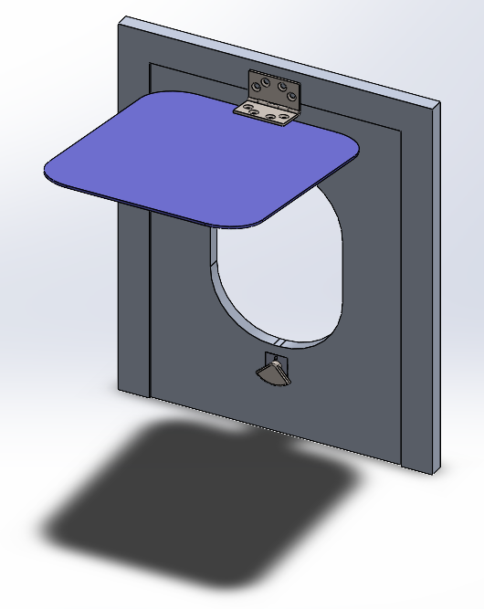 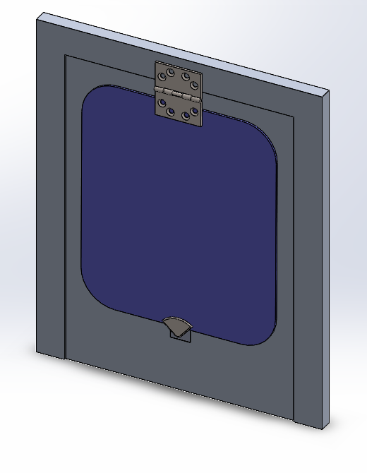

Figure 2: Open Position Figure 3: Closed Position

While consulting with the client, the team came to the conclusion that because the rocket already uses an exterior hinge and aluminum door, these components will not be further designed as the company already has working versions of these components. The team will move forward with purely designing the latching system which will satisfy the client’s needs. Moving on to a more detailed overview of the latching system, it is shown below in figure 4 and a sectioned view is shown in figure 5. The components are a bottom plate, housing, bolt, shaft, torsion spring, pin compression spring and top plate. These can all be seen in figure 5.

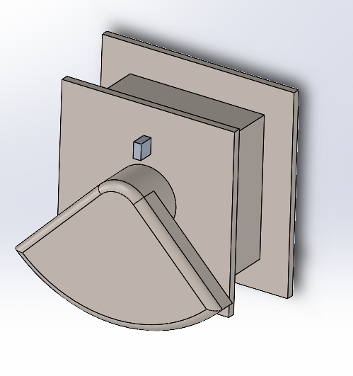 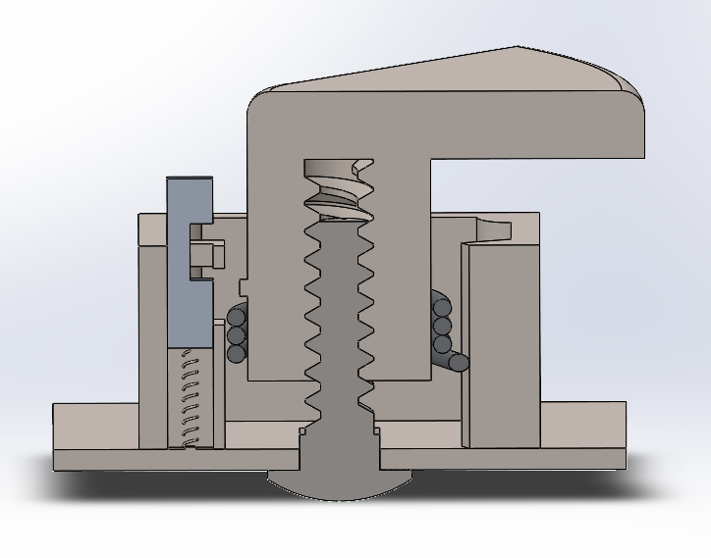

Figure 4: Latch System Figure 5: Latch System Section View

The system works through the torsion spring coiled around the shaft giving the shaft torsional tension. That tension is held by an extrusion on the shaft that is resting on the pin. Once the door shuts closed, it will push the pin down against the compression spring further into the housing. That pin will then reveal an opening that allows the extrusion to pass by which releases all the torsional tension. The shaft will spin 180 degrees down on the bolt causing it to lower slightly and cover the door. The housing has an addition shelf located on the right wall in figure 5. This shelf will block the extrusion and prevent the shaft from rotating further than 180 degrees. The opened and closed views just as the door has shut can be seen below in figures 6 and 7.

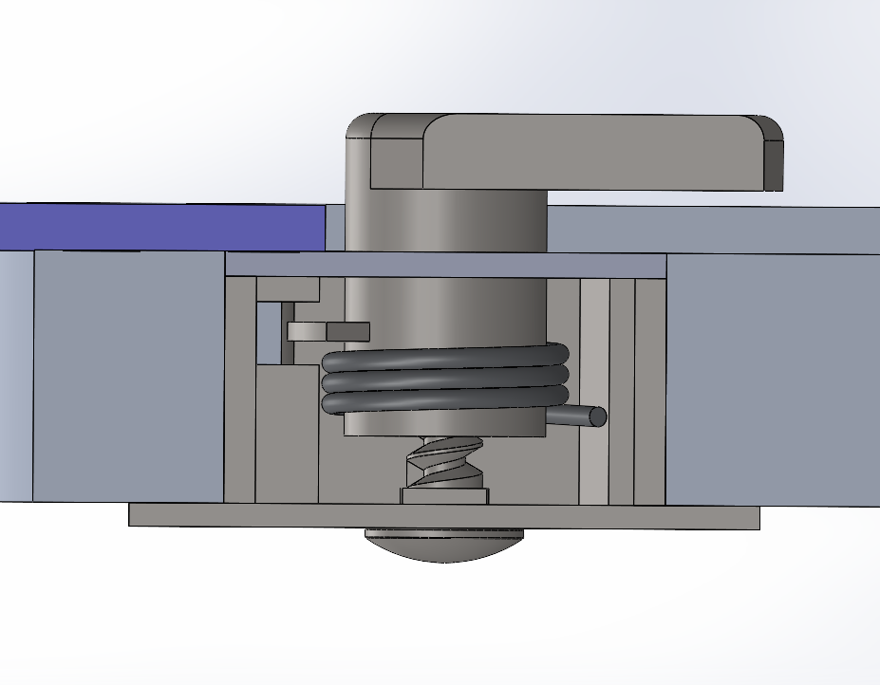 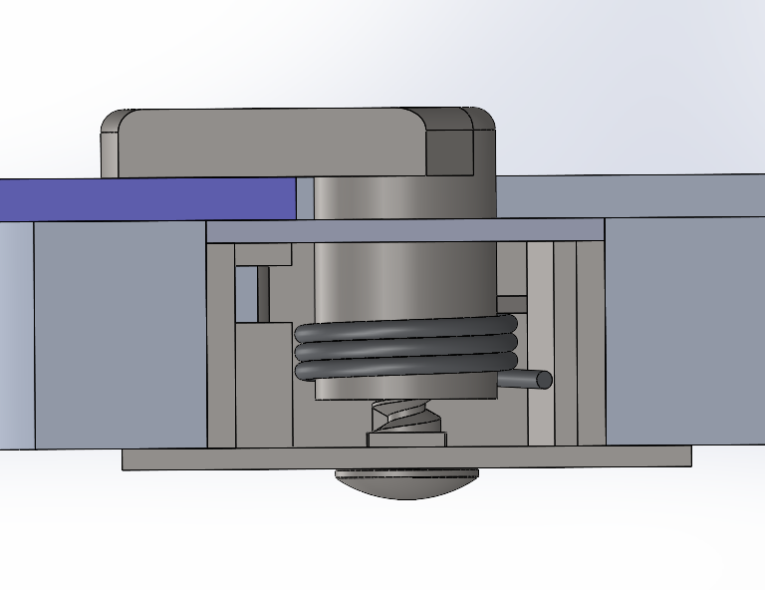

Figure 6: System Side View Opened Figure 7: System Side View Closed

In figure 6 above the door and just shut and the pin has been pushed down. At this time the shaft can now freely rotate. Figure 7 then shows the final closed view of the system after the shaft has turned 180 degrees and the latch portion of the shaft is now covering the door holding it shut. Between figure 6 and 7 the gap between the latch and the door reduces to nothing. This is because while the system is open the is clearing between where the door would lie and the latch. Once the system turned into its closed position, that clearance is removed because the shaft rotates down the threaded bolt. This provides a secure fit of the latch to the door which will increase the resistance to the internal pressure the team is designing for.

The parts will all be made of AISI 304 stainless steel except for the two springs which will be made from music wire. These materials have been selected because they are easily machinable, accessible, and strong. By the preliminary report the team had a very simple latch selected and based on feedback the team chose a much more complex and unique latching design. Now that the final design has been fully detailed, the team’s next steps will be to begin prototyping which is discussed in the next section.

## Implementation Plan

After the PDR presentation, we received different questions on how the design worked and improvements on how the design can adapt better in different situations. We received questions on the selected material, and we were asked to research a more applicable material for this design called 775 Aluminum T-73. This material is what is used frequently in the aerospace industry, especially on the Antares rocket. The engineers also stated that the manufacturing process of this design might be harder than we thought. They gave their input on producing a round pin for ease of manufacturing as dimensions this small will have to have tight tolerances as opposed to a round pin being easily placed in the lathe for manufacturing. Another design implementation would be a round housing and possibly a completely internal housing. The round housing would be useful when installing the housing into the faring, having a round hole cut is less intensive compared to a perfect square. The internal housing was a great consideration considering it would reduce the time necessary to scale up or down the design for different uses. We were also asked about how we could reduce the weight and test for temperature variances in flight. These questions were answered with thought and we are going to be doing further research and analyses into all these design implementations. This will be the first steps into the last weeks of the semester and into winter break, as shown in the Gantt Chart in figure 8.

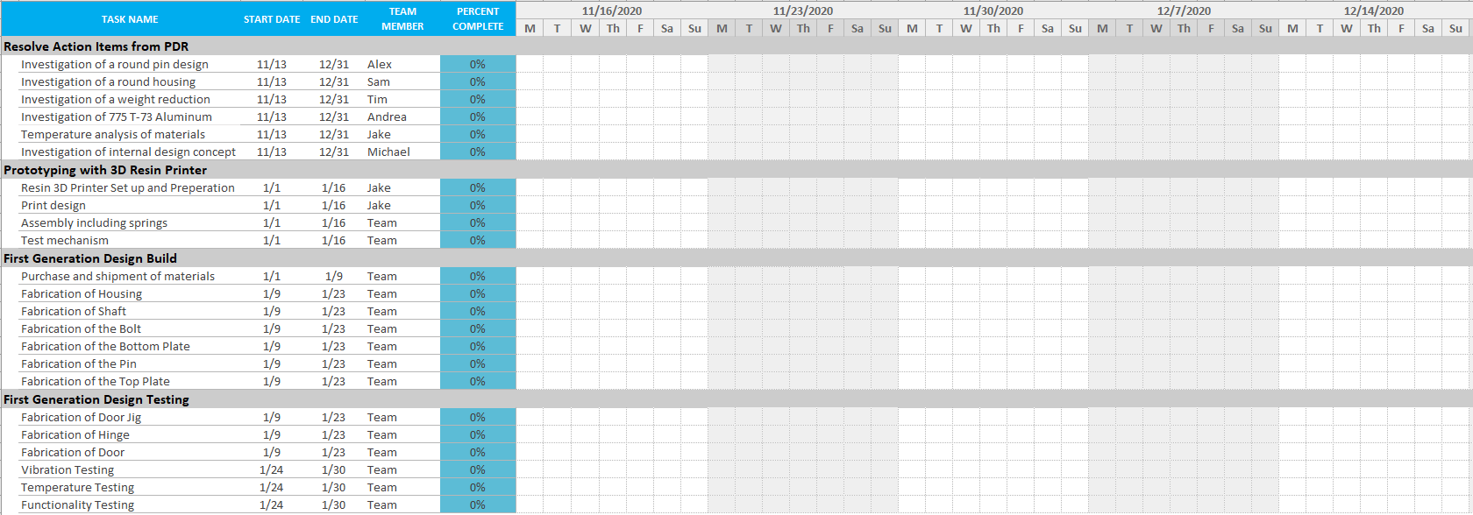

Figure 8: Gantt Chart

The figure above shows the Gantt Chart, a comprised list of objectives and projects to get done in a selected period. The four main projects we need to get done are the action items, prototyping, building, and testing. Each project has subsection objectives assigned with group members, dates, and percentage of completion. These will be tracked over time and filled out in the chart to manage time spent working on the objectives. Once our action items have been analyzed and considered for incorporation into the design, we will begin to prototype and test the assembly and mechanisms. The first course of action is to convert the Solidworks design to be 3D printed and begin to get the 3D printer set up and ready to print in a safe environment. The design will be printed in different parts and then assembled by hand with a material bonder, like superglue. The design will then be tested and analyzed to see if there are any kind of parts colliding or interfering with the overall dynamics of the design.

Once the protype has been evaluated and finalized, the team will move to building and fabricating the parts and ordering the specific items. Table 4 is the complete bill of materials needed to build, fabricate, and prototype our design. This BOM includes one 2.5x2.5x12” piece of AISI 304 Stainless steel that will be used to fabricate at least two of each of the parts needs. This piece will be ordered through metalsdepot.com due to the free shipping benefit they offer [10]. The torsion and compression springs will also be special ordered. The fabrication of the parts will be done by the team members that have their shop certifications at the machine shop on campus, meaning we can fabricate each part for virtually no manufacturing fees. The use of the lathe and CNC machine will be heavy for this portion of the project. If the capstone team is unable to fabricate the parts, we will reach out to Ellison Machinery in Tempe to fabricate our parts.

Table 4: Bill of Materials

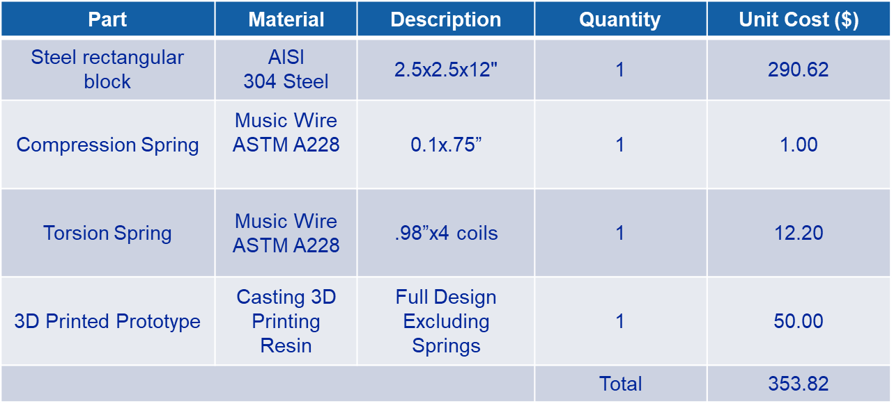

Once the planned design has been fabricated and assembled, we plan to put the design under various stress, vibration, pressure differential, load, and temperature testing stated previously. The budget for the testing is stated in Table 5 and shows that we have set aside $1,000 for testing and prototyping to build a test jig, test hinge, and test door. These will be fabricated in the machine shop with as close to the same materials as possible. The test jib will be a wood frame, with aluminum backing to act as the hole the ECS nozzle inserts into the rocket. The test hinge and door will also be fabricated to be as close to the heritage design as possible, once the deadline approaches, we will reach out to our client, Daniel, to see if we can test the design at their Chandler location to ensure the efficiency of the design. The budgets and planning in this section is subject to change if we continue to improve the design from analyses and testing. The Gantt Chart will be updated for those changes and managed to ensure the project is up to date and flowing efficiently. The final assembly of the design can be shown above in figure #.

Table 5: Budget Planning

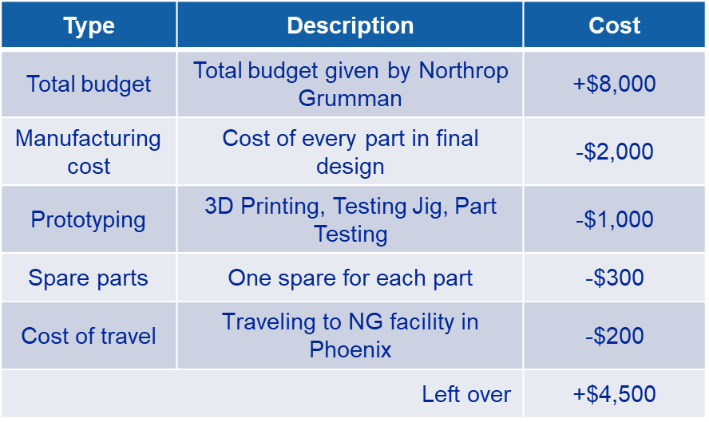

# CONCLUSIONS

For this project, the team was tasked with designing a door that covers the environmental control system inlet in the Antares rocket for Northrop Grumman. The door must be designed to close as the rocket launches, and remain closed during the entire flight. During flight, the system will experience great variances of temperature, high vibrations, and a large pressure differential that it must overcome. The overall design also needs to be reopenable and scalable to other systems.

To achieve all of the requirement stated in the engineering and customer requirements, the team decided to go with a twisting latch design. This design uses an exterior hinge with a torsion spring, just like that on the heritage design. The latching system created is enclosed in a steel housing that fits within the fairing of the vehicle. This steel housing contains a shaft that fits onto a power crew. By placing a torsion spring around the shaft, it will cause the design to rotate when under tension. The devise is loaded while in the open position, and held open by a retaining pin that extrudes out of the fairing. As the door closes, it pushes down the retaining pin, allowing the shaft to rotate. At the top of the shaft is the latch itself, which rotates over the top of the door as it closes. When the latch turns the full 180 degrees, it holds the door in tension, and the friction of the threads prevents the door from opening during flight.

The team plans on prototyping the device using 3D printing, to ensure that the parts fit together well and get a better understanding of what tolerances are the most important. After the first prototype, the team will begin manufacturing metal versions to test the stresses of the design. The team plans on making a test jig to simulate the nozzle being removes, and the door shutting on the latch. The team must also test the vibrations, pressure differential, and loads that the device could be experiencing in flight. These tests will simulate the actual experience, and give an in depth look at any faults in the device that may warrant a redesign.

# REFERENCES

[1] “Antares Rocket,” Northrop Grumman. [Online]. Available: https://www.northropgrumman.com/space/antares-rocket/. [Accessed: 19-Sep- 2020].

[2] “Northrop Grumman Cargo Launch to the Space Station from NASA Wallops - YouTube.” [Online]. Available: https://www.youtube.com/watch?v=tQW_2qtBDfY. [Accessed: 12- Oct- 2020].

[3]  “Pegasus Rocket – Northrop Grumman.” [Online]. Available: https://www.northropgrumman.com/space/pegasus-rocket/. [Accessed: 17-Oct-2020].

[4] ASM Material Data Sheet. [Online]. Available: http://asm.matweb.com/search/SpecificMaterial.asp?bassnum=MQ304A [Accessed: 12-Nov- 2020].

[5] Budynas, Richard G, J K. Nisbett, and Joseph E. Shigley. Shigley's Mechanical Engineering Design. New York: McGraw-Hill, 2011. Print.

[6] “Definitive Guide to Tormach Hacks, Upgrades, and Modifications.” [Online]. Available: <https://www.cnccookbook.com/tormach-upgrades-hacks-modifications/>. [Accessed: 11-Nov-2020].

[7] “(6) Protolabs: Overview | LinkedIn.” [Online]. Available: https://www.linkedin.com/company/proto-labs/. [Accessed: 11-Nov-2020].

[8] “Aluminum Honeycomb Panels,” McMaster-Carr. [Online].  Available: https://www.mcmaster.com/aluminum-honeycomb-panels/. [Accessed: 11- Oct-2020].

[9] “Aluminum stock” MetalsDepot. [Online]. Available: <https://www.metalsdepot.com/aluminum-> products/aluminum-square-bar. [Accessed: 11-Oct-2020].

[10]  MetalsDepot® - T304 Stainless Steel Square Bar. [Online]. Available: https://www.metalsdepot.com/stainless-steel-products/stainless-steel-square [Accessed: 11-Nov-2020].

# APPENDICES

## Appendix A: House of Quality/QFD

